Structure Charts — Resume Service

SC Figure 1.7.0.3 — saveResume()

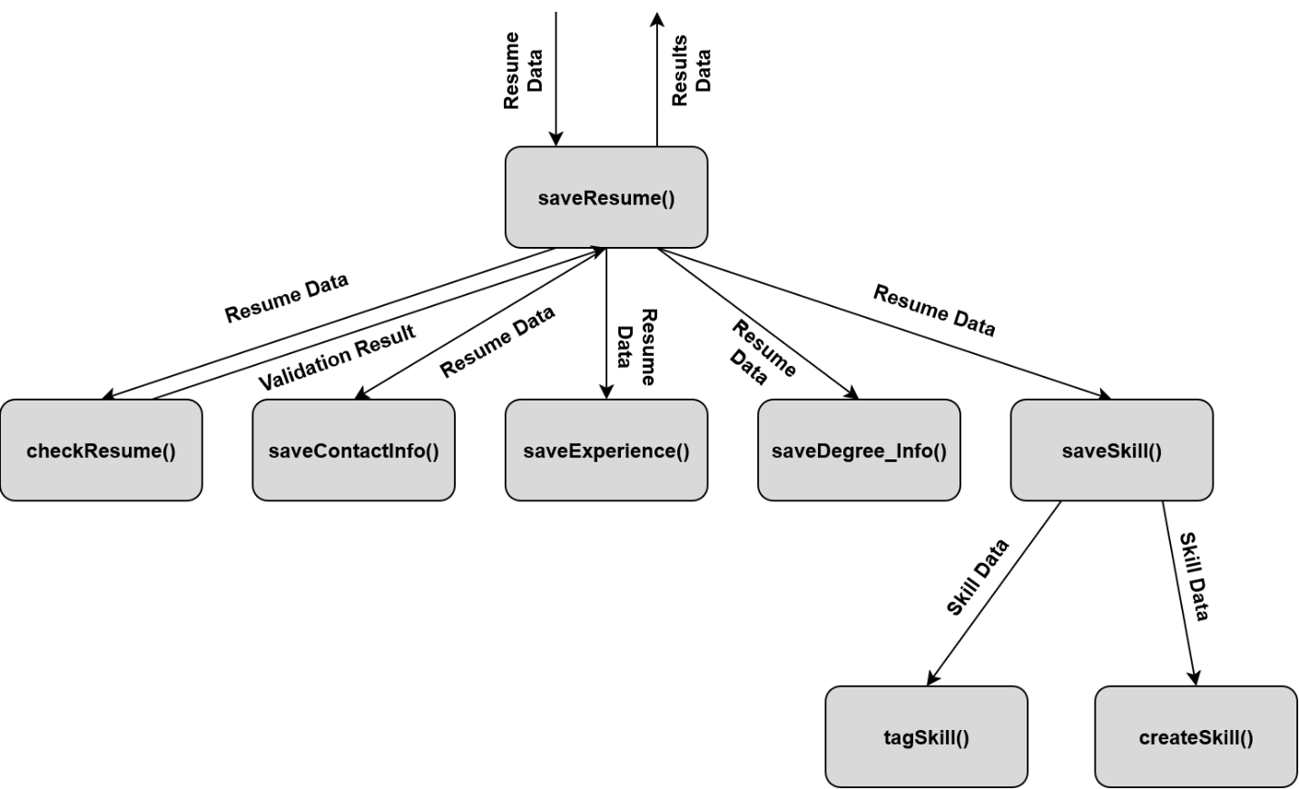
SC Figure 1.7.0.4 — checkResume()

